Code of Conduct

All members of group A hereby agree upon the below-stated clauses and acknowledge that they have read and signed them.

**Roles**

* Team Leader
* Co-leader

*The team leader will be chosen based on the chosen project. The Co-leader will be chosen by the team leader.

* Quality Control: Mihaela Covali
* Quality Control: Erika Nicolau
* Quality Control: Jia Men Lam
* Quality Control: Daryl Genove
* Room Manager: Timofei Arefev
* Implementer: Peter Zlamala
* Secretary: Mihael Druzeta

**Meeting**

* Always held at a specific time.
* Meetings should be flexible.
* Listen to each other and try not to interrupt your teammates.
* The Secretary creates a transcript of events, ideas “to-do”-s, and responsibilities of the meeting, the secretary will change from meeting to meeting.
* The records must be shared on the team's Google Drive after every meeting session.
* Members who were not present during a meeting must be up to speed on meeting developments.
* Members must communicate ASAP about an inability to attend meetings.
* Members must communicate any delays regarding their arrival at the meeting, do not be late more than 15 minutes to a meeting.
* Do not slack off during meetings, nor conduct activities such as sleeping and staying on your phone.

**Standardization**

* For quality control purposes members must submit their work no later than 23:59, 2 days before the official deadline.
* Ensure your products contain no major errors before being submitted for quality control.
* Follow the standardization guidelines set by the group.

**Respect and Conduct**

* Plagiarism of any sort is not tolerated.
* All team members must be treated with respect and practice solidarity within the group.
* Every team member’s opinion must be thoroughly considered.
* If disagreements occur, these must be discussed in a civilized manner.
* When reviewing another team member’s work, provide constructive criticism where applicable.
* Do not change others’ work without consulting with them first.
* All group members must contribute equally towards the group’s tasks.
* All decisions in the group must be made democratically.
* All group members should speak in English so that everyone can understand what is being said. It is to be stated that there are certain exceptions to this rule for the sake of clarity.
* Voice your opinion in a respectful manner.
* Be presentable during meetings and when time is spent with the group.

**Commitment**

* Be reachable during working days (9:00-17:00), if it has been previously agreed by the team, be available on the weekends when necessary.
* When doing ateliers from home be contactable and ready to communicate with team members.
* When finished with your work, help others as needed.
* Be willing to discuss group matters during free hours to allow for ateliers to be done from home.

**Strike system**

* Strikes may only be given when the whole team agrees to the strike. Any indiscretion to the clauses below will result in a strike.
  + If a team member is 15 minutes late to a meeting or does not show up without warning.
  + They do not meet the deadlines set by the team or otherwise.
  + Disrespect to a team member's character or work.
  + If a team member does not complete their work.
* After 3 strikes a lecturer will be notified of the issues with the team members along with evidence to support the strikes.

**Working conditions**

* Repeated violation of coding standards, not following established guidelines, or introducing unauthorized changes.
* Failure to complete assigned tasks without valid reasons or continuous delays.
* Consistent lack of contribution, refusing to work with team members, or hindering collaborative efforts.
* Engaging in disruptive conflicts, refusing to resolve issues, or creating a hostile working environment.
* Unprofessional behavior such as gossiping, spreading rumors, or undermining team morale.
* Unauthorized use or manipulation of project resources, including code, documentation, or data.
* Persistent negativity, discouragement of team members, or consistently dismissing others' ideas without constructive feedback.
* Consistent submission of code with known issues, neglecting feedback from code reviews, or failing to address identified problems.
* Consistent refusal to acquire necessary skills or neglecting opportunities for professional development.
* Writing code that intentionally violates ethical standards, compromises security, or invades privacy.
* Withholding critical information, refusing to share knowledge, or hindering the learning and growth of other team members.
* Consistent disruptive behavior during meetings, lack of engagement, or distracting team members from the meeting's purpose.
* Stubbornly refusing to consider alternative solutions, dismissing feedback without consideration, or consistently resisting constructive criticism.

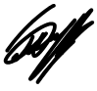Mihaela Covali

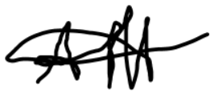**Timofei Arefev**

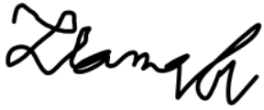**Peter Zlamala**

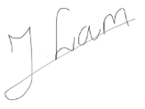 **Jia Men Lam**

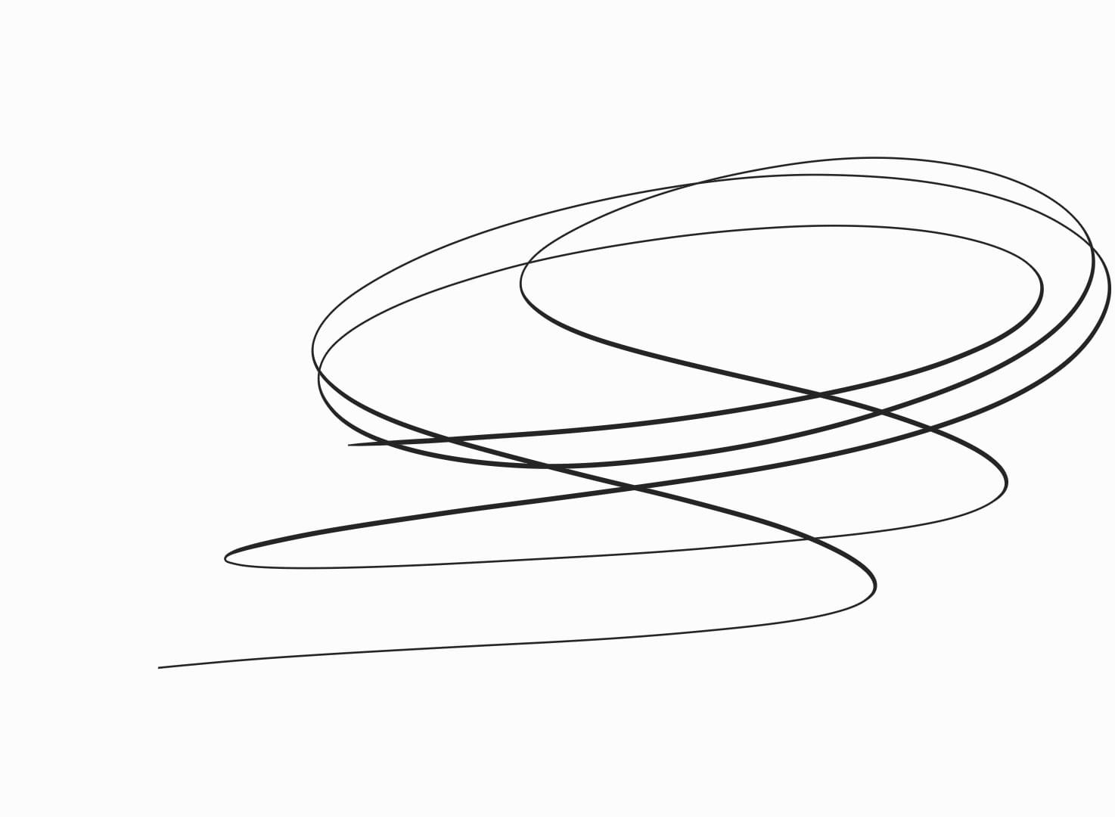 Daryl Genove

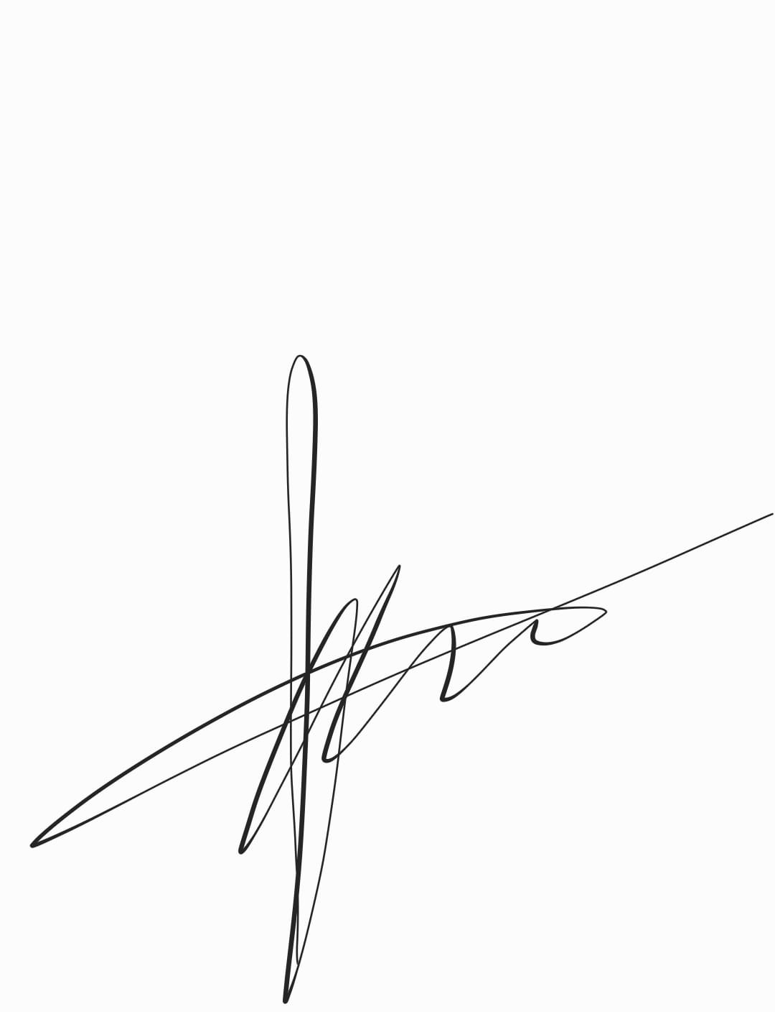 Mihael Druzeta

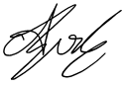Erika Nicolau